Final Project Report (06/15/17)  
COMS 6901 E sec:50 Spring-2017

*Atif Ahmed* [*aa3931@columbia.edu*](mailto:aa3931@columbia.edu)  
*Abstract:* Development of visualizations using d3.js [1] and other technologies for the iCAGES [2] project to help in the optimization of the neural network architecture.

*Introduction:* iCAGES stands for integrated CAncer GEnome Score. It is a statistical framework for comprehensively prioritizing driver genes in personal cancer genomes. It infers driver variants by integrating contributions from coding, non-coding, and structural variants, identifies driver genes by combining genomic information and prior biological knowledge, then generates prioritized drug treatment.

iCAGES also uses a deep learning group lasso cox model that integrates molecular, demographical and clinical profiles of cancer patients to their survival outcomes. These clinical profiles of the patients contains high dimensional data with around 4000 features. Since many of the features are related in real world, a group lasso model is used so that similar features are grouped together.

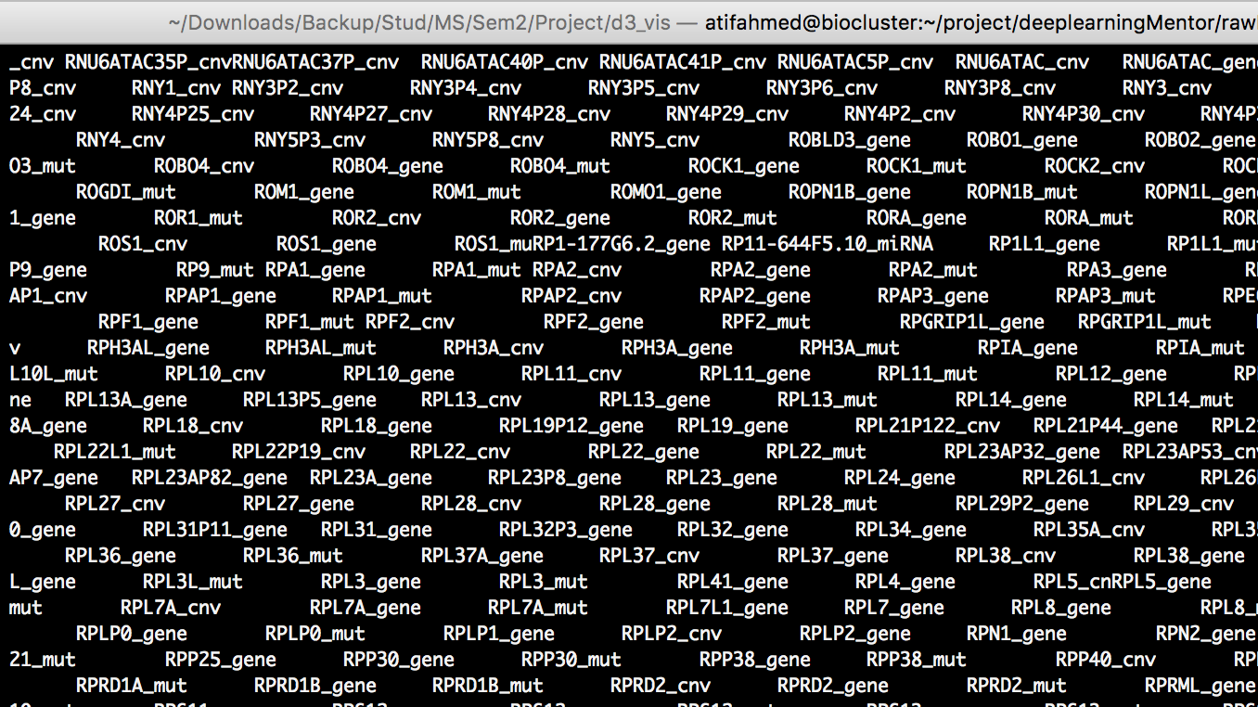

Figure 1: Command-line output showing some of the feature names. Feature names starting with similar prefix are related (e.g. RPF1_gene and RPF1_mut)

The deep learning model initially used in iCAGES consists of only 2 layers (1 hidden and 1 output layer). Even though this model significantly outperforms alternative methods, such as cox regression with L1 penalty, L2 penalty and deep learning models with no penalty added, it can be further improved by fine-tuning the neural architecture. So, the main task of this project was to build a tool to visualize:

* different configurations of hyper-parameters such as number of hidden layers, number of hidden units, number of iterations, choice of activation function, etc..
* how the neural network is working at each iteration.
* how the accuracy and cost are changing at each iteration.
* how the predicted result for each patient is changing at each iteration

*Architecture:*

1. The configuration of the neural architecture being used is stored in the runDeep.py file. These configurations are read by parse.py file.
2. The neural network produces 4 output files. These output files are read by parse.py.
3. The parse.py file converts the plaintext output files to serialized json files. These json files can then easily be read by d3.js.

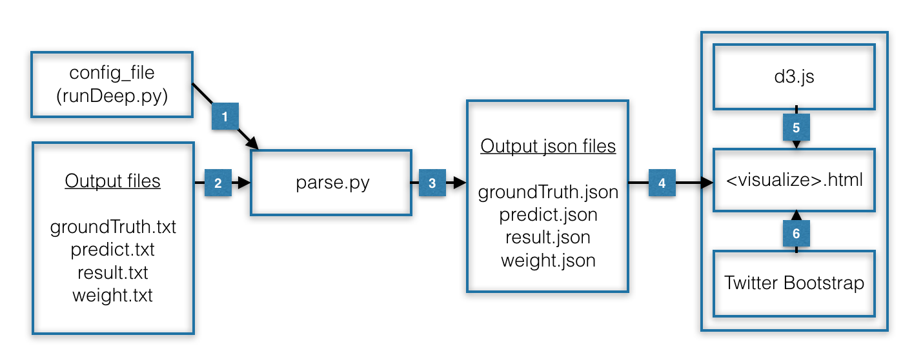

Figure 2: Interaction of different components in the visualization process.

1. The json files are read by different visualization html files.
2. The d3.js library is used by the visualization files to create the visualizations.
3. Twitter bootstrap [3] is used to prettify the produced html pages.

*Technical Details:*

* First parse.py is run for converting the output files to their corresponding json format as:   
  `*python parse.py*`  
  Inside *parse.py*, first we need to set the *config_file* parameter which is basically the path to the file *runDeep.py*. The *parse.py* script:
  + parses the configuration file to get the neural network parameters like the number of hidden layers, number of iterations, lambda, alpha and the non-linear layer.
  + reads the prefix string which is basically the path at which the output files are stored.
  + creates a unique directory for this run by using a combination of all the neural network parameters and prefix string.
  + parses the output files one-by-one, converts them into a json format and stores in the unique directory created.
  + for predict probability values, if the output file contained some value greater than 1.0, it was made equal to 1.0 in the json output.
* The unique directories containing the json output files will then be used by the visualization html files.
* All the visualization html files are then hosted on a server. Either SimpleHTTPServer [4] of python can be used by running the following in the directory containing the html files:  
  `*python -m SimpleHTTPServer <port_number>*`  
  or it can be hosted on Github Pages [5]. In case of SimpleHTTPServer, the visualizations can be seen at the address `*localhost:<port_number>*` in the browser.
* The file *index.html* [6] shows a list of all the visualizations created for this project. Many of the visualization files use the json data created above and therefore need to be configured with the correct path to the relevant files in the javascript code.
* The full visualization contains 2 buttons: ‘Start Visualization’ and ‘Stop visualization’. It also contains various dropdown menus to select the hyper-parameter values to select the configuration. After choosing the configuration, ‘Start Visualization’ should be pressed. For changing the configuration, ‘Stop Visualization’ should be pressed and then the new configuration should be chosen. Whenever a new configuration is chosen, the javascript code finds the particular unique directory containing the output json file for that configuration and then loads the content for the visualization.

*Methods/Steps followed during the project:*

* Read the iCAGES paper [7] and Chapter 3 of Dr. Dong’s thesis for better understanding of the neural architecture.
* Learnt TensorFlow:
  + Implemented Softmax regression on MNIST dataset.
  + Implemented a mulitilayer perceptron for MNIST dataset.
  + Implemented a convolutional neural net for MNIST dataset.
  + Uploaded an article based on my learnings to Labshare/Analysis repository [8].
* Learnt Keras:
  + Used TensorFlow as backend and implemented a convolutional neural net for MNIST dataset.
* Learnt d3.js:
  + Followed d3js.org tutorial to create basic visualizations.
  + Followed video tutorial series by d3Vienno [9]. Notes are uploaded at [10].
* Understood Github code:
  + Went through the WGLab/icages repo and understood the main perl script.
  + Installed the setup and ran iCAGES tool. Tested basic example for better understanding.
* Preprocessing:
  + Output produced by the model is stored in 4 different files:
    - test...predict.txt
    - test...groundTruth.txt
    - test...result.txt
    - Test...weight.txt
  + Here ‘…’ is the part of the name which depends on the configuration of the neural architecture.
  + These are simple non-serialized text files which
* Developing basic prototypes:
  + First tried to visualize the flow diagram of iCAGES architecture (*graph.html*). d3 official examples [11] were used for this.
  + Then tried to visualize circles with their color density according to the magnitude of a list of numbers (*circles.html*).
  + Created a visualization that updated like a time series when input list of numbers is given (*updatingPath.html*). Followed a tutorial [12] for this.
  + Created basic network of circles and lines to show a network architecture (*test.html*).
* Developing separate visualizations:
  + Developed a network architecture which also shows the network output probabilities dynamically being updated at each iteration (*network.html*).
  + Developed a visualization of predicted probabilities which shows a circle for each patient and dynamically changes the color density based on the predicted probability at that iteration (*predict.html*).
  + Created dynamic time plots for accuracy and cost which updates at each iteration (*results.html*).
* All the separate visualizations were then combined to create a full visualization which are synchronized to update their respective visualization components at each iteration (*full.html*). The full visualization also shows various dropdown menus for choosing the various hyper-parameter configurations. The values are hard-coded right now but can easily be configured to load according to the available output files. Also, right now only non-linear dropdown menu has been coded to change the configuration. Other menus can be coded in a similar way.

*Technologies used:*

* d3.js for all the visualizations.
* Python for converting text data to d3-readable json files.
* SimpleHTTPServer for local web hosting and Github pages for hosting on Github.
* Twitter Bootstrap for prettifying the user interface.

*Conclusion and Results:*

* All the initial objectives and requirements for the visualizations were achieved.
* There’s still a lot of improvements that can be done. Some of them are suggested in the future work.

Screenshots of some of the test runs can be seen here:

* Visualization of predicted probabilities for each patient for each iteration (click to see the animation).  
  
* Visualization of the network accuracy and cost at each iteration (click to see the animation).   
  

*Future work:*

* We need to be able to show weight changes on the architecture.
* We need to be able to change even more hyperparameters.
* Use something like convnet.js [13] to make everything only on browser and specific to our dataset and network (e.g. playground.tensorflow.org [14]).

*References:*

[1] <https://d3js.org/>

[2] <http://icages.wglab.org/>

[3] <http://getbootstrap.com/>

[4] <https://docs.python.org/2/library/simplehttpserver.html>

[5] <https://pages.github.com/>

[6] <https://wglab.openbioinformatics.org/GDNNP-visualization/>

[7] <https://genomemedicine.biomedcentral.com/articles/10.1186/s13073-016-0390-0>

[8] <https://github.com/WGLab/LabShare/tree/master/Analysis/TensorFlow_Tutorial>

[9] <https://www.youtube.com/user/d3Vienno>

[10] <https://github.com/WGLab/GDNNP-visualization/blob/master/notes/notes.txt>

[11] <https://github.com/d3/d3/wiki/Gallery>

[12] <http://bl.ocks.org/benjchristensen/1148374>

[13] <http://cs.stanford.edu/people/karpathy/convnetjs/>

[14] <http://playground.tensorflow.org/>

